**OOP LAB 10**

**TASK 1**

#include <iostream>

#include <string>

using namespace std;

class Employee

{

string name;

string DoB;

string CNIC;

string age;

public:

Employee(string n = "", string d = "", string c = "", string a = "") :name(n), DoB(d), CNIC(c), age(a) {}

friend void setData(Employee&);

friend void getData(Employee&);

friend void display(Employee&);

};

void setData(Employee&r)

{

r.name = "";

r.DoB = "";

r.CNIC = "";

r.age = "";

}

void getData(Employee &r)

{

cout << "Enter Name: ";

cin >> r.name;

cout << "Enter Date of Birth: ";

cin >> r.DoB;

cout << "Enter CNIC: ";

cin >> r.CNIC;

cout << "Enter Age: ";

cin >> r.age;

}

void display(Employee& r)

{

cout << "---------------------------------" << endl;

cout << " Your Information " << endl;

cout << "---------------------------------" << endl;

cout << "\nName: " << r.name << endl;

cout << "Date of Birth: " << r.DoB << endl;

cout << "CNIC: " << r.CNIC << endl;

cout << "Age: " << r.age << endl;

}

int main()

{

Employee obj;

getData(obj);

display(obj);

return 0;

}

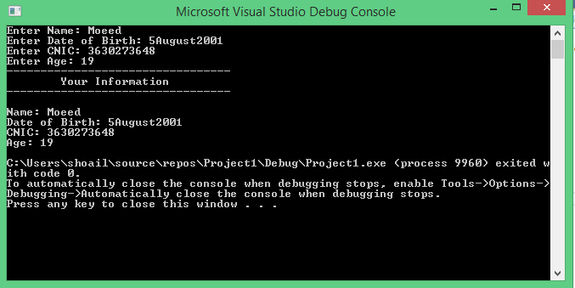

**TASK 2**

#include <iostream>

#include <string>

using namespace std;

class Circle {

private:

double radius;

string color;

public:

Circle(double radius = 3.0, string color = "Black");

double getRadius() const;

void setRadius(double radius);

string getColor() const;

void setColor(string color);

};

Circle::Circle(double r, string c) {

radius = r;

color = c;

}

double Circle::getRadius() const {

return radius;

}

void Circle::setRadius(double r) {

radius = r;

}

string Circle::getColor() const {

return color;

}

void Circle::setColor(string c) {

color = c;

}

int main()

{

Circle c1(8.5, "White");

cout << "Radius is: " << c1.getRadius() << endl;

cout << " Color is: " << c1.getColor() << endl;

c1.setRadius(12.5);

c1.setColor("Purple");

cout << "Radius is: " << c1.getRadius() << endl;

cout << " Color is: " << c1.getColor() << endl;

Circle c2;

cout << "Radius is: " << c2.getRadius() << endl;

cout << " Color is: " << c2.getColor() << endl;

return 0;

}

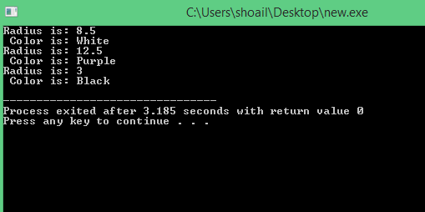

**TASK 3:**

#include <iostream>

using namespace std;

class Temperature {

double celsius, kelvin, fahrenheit;

public:

friend void input(Temperature&);

friend void CalculateAndDisplay(Temperature&);

};

void input(Temperature& r)

{

cout << "Enter temperature in Celsius: " << endl;

cin >> r.celsius;

}

void CalculateAndDisplay(Temperature& r)

{

r.kelvin = r.celsius + 273.15;

r.fahrenheit = (r.celsius * 9.0) / 5.0 + 32.0;

cout << " \nTemperature in Celsius: " << r.celsius << endl;

cout << " \nTemperature in Kelvin: " << r.kelvin << endl;

cout << " \nTemperature in Fahrenheit: " << r.fahrenheit << endl;

cout << endl;

}

int main()

{

Temperature temp;

input(temp);

CalculateAndDisplay(temp);

return 0;

}

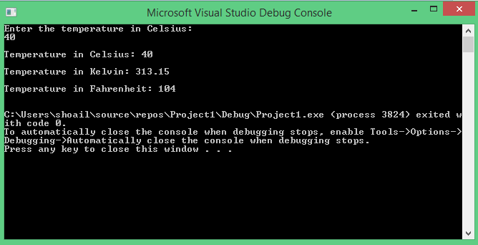

**TASK 4:**

#include <iostream>

using namespace std;

class Rectangle

{

int length, breadth;

public:

Rectangle(int l = 0, int b = 0) :length(l), breadth(b) {}

friend void display1(Rectangle&);

friend void display2(Rectangle&);

};

void display1(Rectangle & r)

{

cout <<" "<< "Length" <<" "<< "Breadth" << endl;

cout << "Rectangle 1: " <<" " << r.length << " " <<r.breadth << endl <<endl;

cout << "Sum: " << r.length + r.breadth << endl;

}

void display2(Rectangle& r)

{

cout << "\nRectangle 2: " << " " << r.length << " " << r.breadth << endl << endl;

cout << "Sum: " << r.length + r.breadth << endl;

}

int main()

{

Rectangle rect1(5, 5);

Rectangle rect2(6, 10);

display1(rect1);

display2(rect2);

return 0;

}

